Sample Project
Title: Railway_Guages
First, we have to import required library. Then we have to import the CSV file into Pandas library.
Pandas is a powerful data analysis library providing flexible way to do data manipulation. There are many mathematical and scientific computational features can be leveraged using this library.
Matplotlib is a Python library used for data visualization it helps you create graphs and charts from data. It’s one of the most popular tools in Python for plotting.
In order to load the CSV file using Pandas, we need to do the following step.
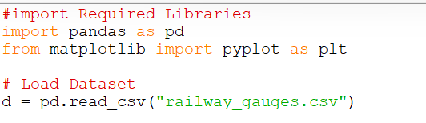
Pandas returns as Data frame object. Using data frame object, we can see the top 5 rows using head() function and tail() function to display last 5 rows in a CSV file. In our above example, we have used df.head(), it displays first 5 rows in the loaded CSV. Here I am displaying first 5 & last 5 rows and columns.
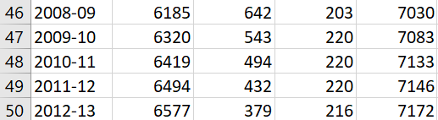
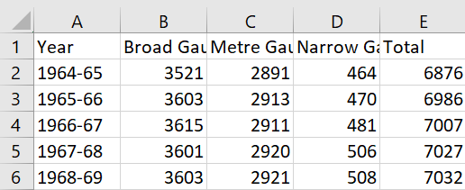
Using head() it displays first 5 rows from dataset. Using tail() it displays last 5 rows from dataset.

- Using Matplotlib we can plot the data flow in graphical representation format. Plotting bar graph for the above given years.
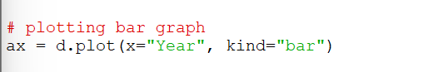
Now, adding title and labels to the bar
- Title: The title is the main heading of the graph. It tells what the whole graph is.
- Label: Labels describe the axes (sides of the graph).
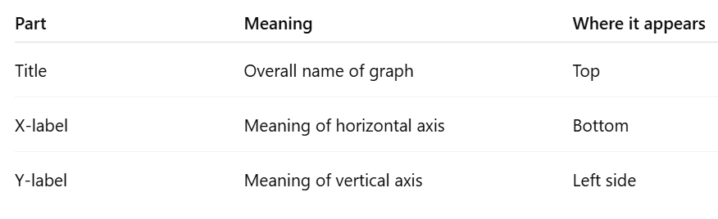
- Title = what the graph shows overall
- X-axis = Year data
- Y-axis = Total number of gauges
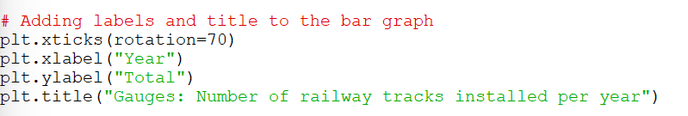
- After finishing the required steps then we need to save the output figures and then display the output graphs.
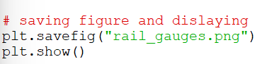
- And the output graph look likes in below.
